## Documentation for roisub

Roisub is a GUI programed in MATLAB and runs best with version R2016a and b. This GUI allows you to process calcium imaging videos recorded with doric’s microendoscope and at the same time evaluate the behaviour of the mouse.

#### Overview of the GUI

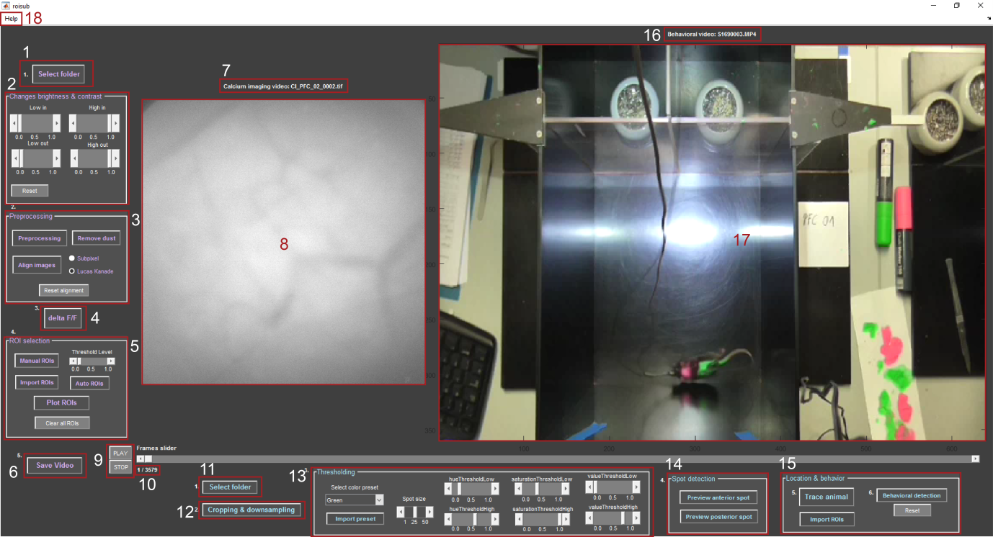

1: select the folder of the calcium imaging video

2: change brightness and contrast of the raw video

3: process the video by down sampling, eliminating glitches, and performing flatfield correction; optionally mask dust or align images

4: calculate the change of the video over time with deltaF/F

5: find cells by manual ROI selection or automatic detection

6: save deltaF/F or raw video with activity in a red mask as AVI

7: name of the current calcium imaging video

8: calcium imaging video

9: play and stop button to control playing of the video(s)

10: showing current frame/total frames

11: select the folder of the behavioural video

12: performs down sampling and cropping of the behavioural video

13: define mask showing one or two colour spots of the animal

14: previews and saves one or both colourful spots of the mouse with the specified mask

15: trace location of the animal and correlate that with the cell activity found with the calcium imaging video, as well as what behaviour the mouse shows

16: name of current behavioural video

17: behavioural video

18: Help tab with documentation for using roisub

## CONTENT

I Workflow to process the calcium imaging video

1. Select Folder
2. Optional: remove dust
3. Pre-processing
4. Optional: image alignment
5. Delta F/F calculation
6. Cell detection/ ROI selection
7. Calculating values and plotting calcium traces
8. Optional: save video
9. After processing behavioural video: re-plot calcium traces with behaviour

II Workflow to process the behavioural video

1. Select Folder
2. Crop and down sample the video
3. Define mask for tracking colour spot(s) of the animal
4. Preview and save tracking
5. Trace the animal and plot locations correlating with cell activity
6. Behavioural detection

## I Workflow to process the calcium imaging video

#### Select Folder

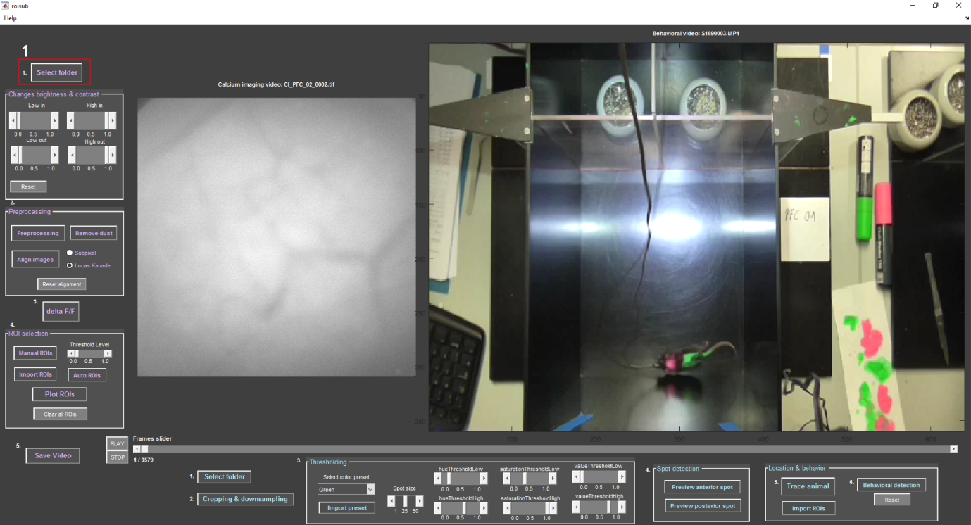

First select the folder where your calcium imaging video is located (1). Please have only one TIFF stack per folder. You can provide a simple text file with a number describing the frame rate; however, if a text file is not present, you will be asked for the frame rate manually.

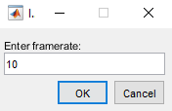Next you will be asked if you need help with the software. If you choose yes, help messages will be displayed throughout the program to provide instructions. If you choose no, these help messages will be suppressed.

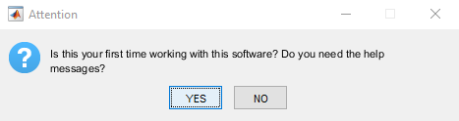When the video is loaded, you can adjust the brightness and contrast by changing the values for “high in”, “high out”, “low in”, and “low out”.

In case you already worked with this video before, you will be asked if you want to load your last version (below). By choosing “yes” your lastly saved progress will be loaded, by choosing “no” the program will load the raw video.

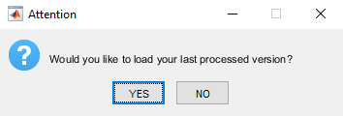

#### Optional: remove dust

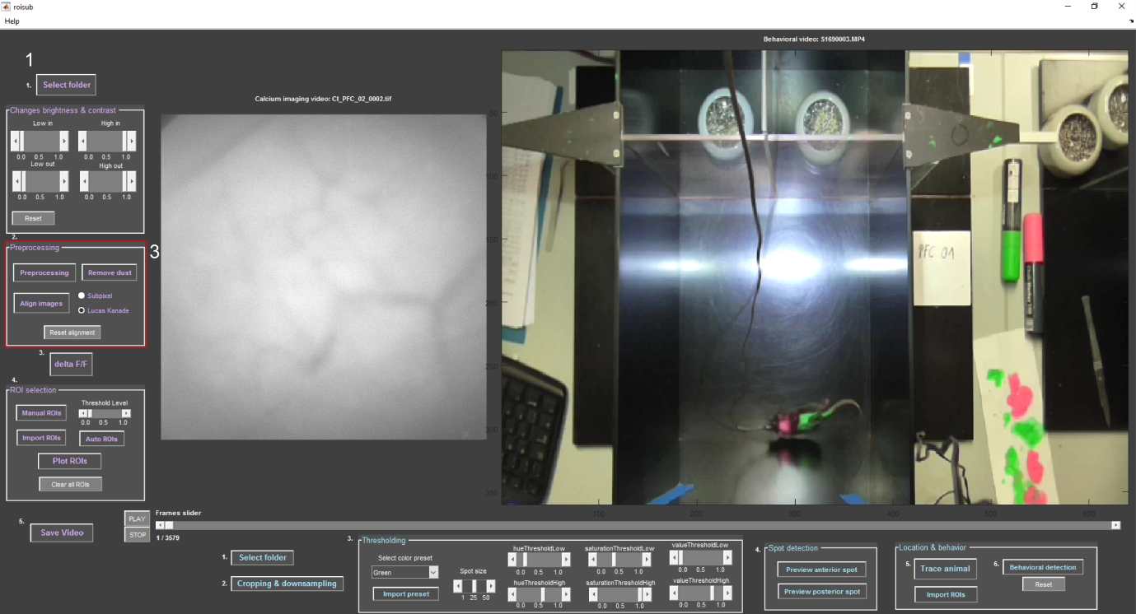

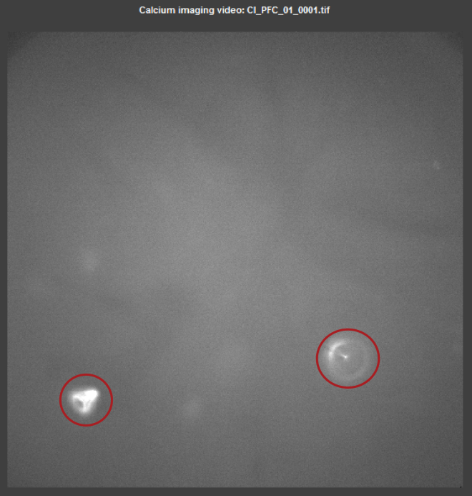You can remove dust or other static irregularities (circled in red) from your video by pressing “remove dust” (3).

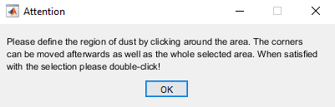The pop-up explains how to select the area (above). You click around the area of interest and once you are finished, double-click (below).

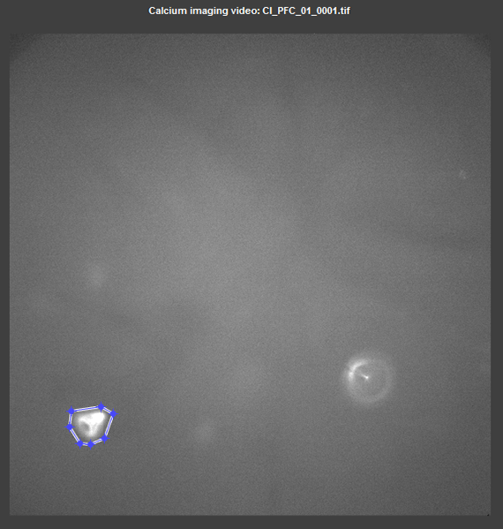The code will fill the area with a mean value of the neighbouring pixels (below).

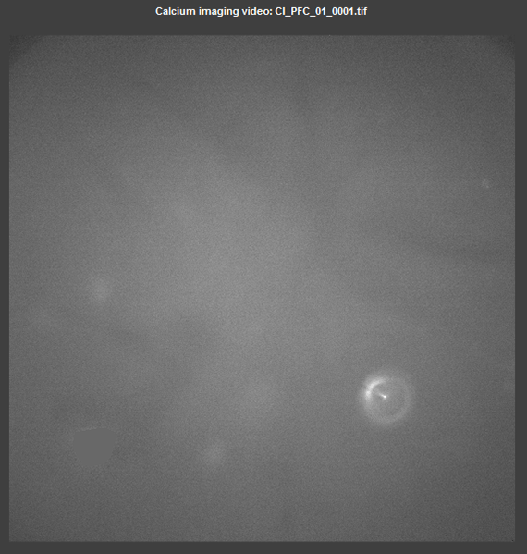

#### Pre-processing

**

The first step of pre-processing (3) involves down sampling the calcium imaging video to 40% of the original resolution. Next the video is searched for dropped frames, e.g. completely black frames. Those frames are substituted by the previous frame. Lastly, the video is corrected for the brightness gradient (darker at the edges, lighter in the middle) by flat field correction. Flat field correction divides every image by an averaged image of the video and multiplies it with the maximum value of the first image. Additionally it cuts out the middle 80% of the video such that the borders are discarded (result is shown below).

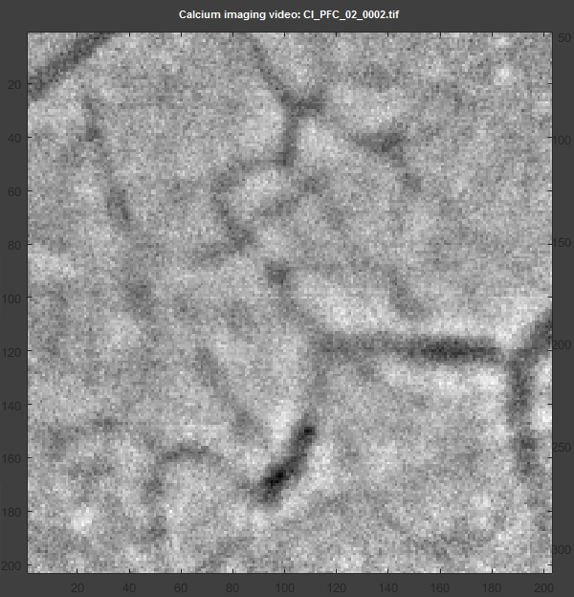

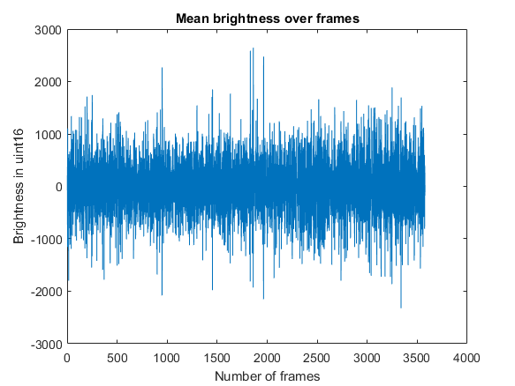Pre-processing gives out a graph showing the mean brightness over time (above). This is to see, if there are any major changes in global brightness, either due to photo bleaching or other events. This graph is saved in your origin folder.

#### Optional: image alignment

**

If your video is shaky, you have the option to align the images with two different algorithms: the sub-pixel image registration or the Lucas Kanade algorithm (3). The sub-pixel registration works only in few cases, so it is recommended to use the Lucas Kanade algorithm. Select the Lucas Kanade radio button and press “align images”. You will be asked to define a ROI. The ROI should contain some distinctive features like blood vessels (see below).

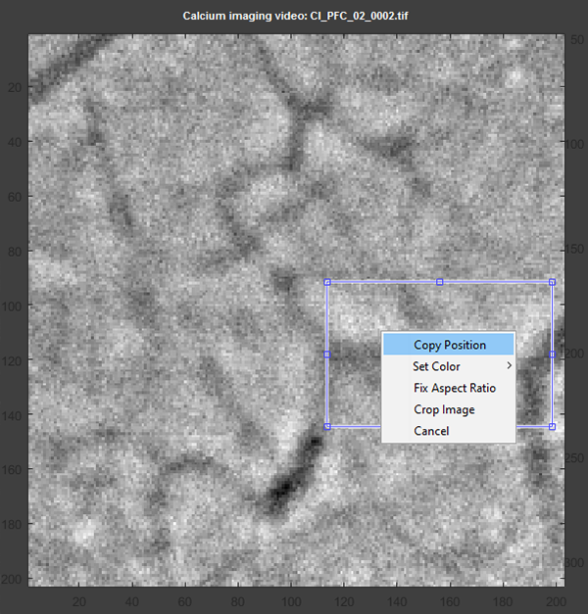

Once the area is selected, right-click, select “copy position”, and follow the import wizard by clicking “next” and “finish” (below). The import wizard imports the coordinates of the defined ROI.

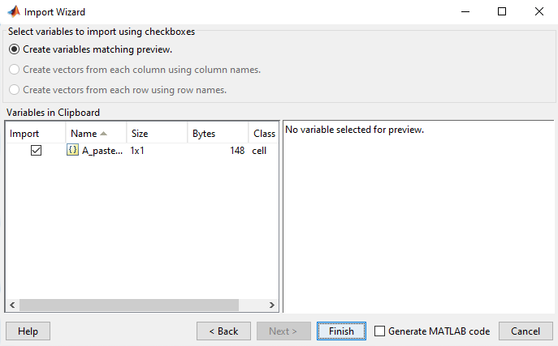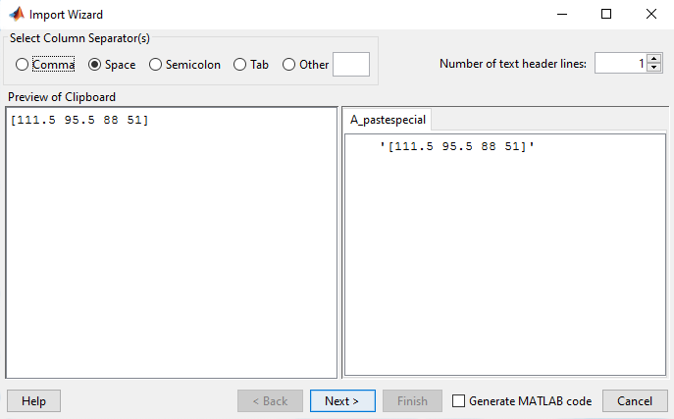

The ROI is enhanced by maximizing contrast, sharpening, and noise filtering, to have best possible distinction of the features in the image (e.g., the blood vessels). This processed ROI is then further used by one of the two alignment algorithms:

Lucas Kanade: It computes the geometric transformation that should be applied to match one image to another. The optimal transformation is the one that minimizes the squared image difference between both images. The transformation vector that is found aligning the ROI is then used on the whole video.

To reset alignment use the respective button.

#### Delta F/F calculation

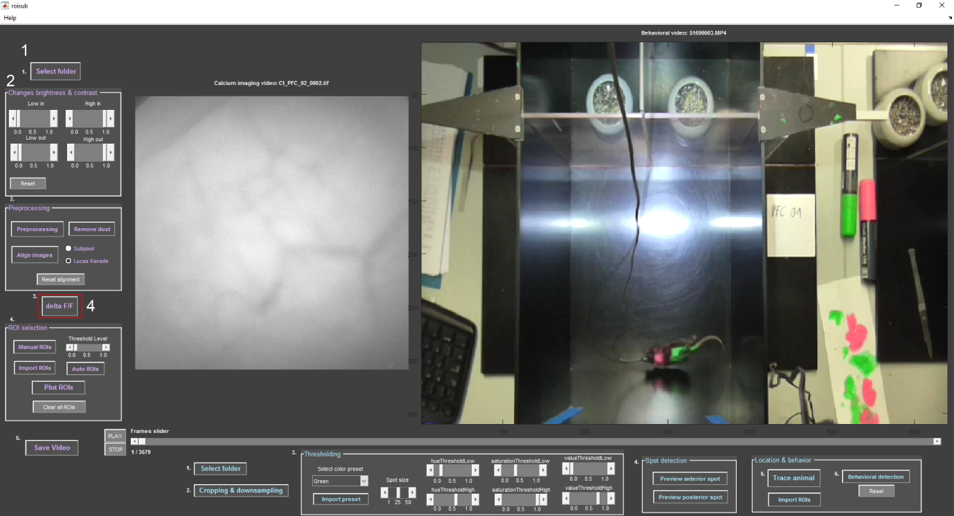

In order to enhance cell activity and eliminate noise, the ∆F/F method is commonly used (4). This method uses the mean of all video frames and first subtracts the mean frame form each individual video frame, then divides the result by the mean frame:

$$\frac{∆F}{F}= \frac{{frame}_{i}-mean(video)}{mean(video)}$$

Additionally, we use a Gaussian blur on the whole video, result can be seen below. Notice that blood vessels are almost invisible, and a bright cell is visible in the upper middle.

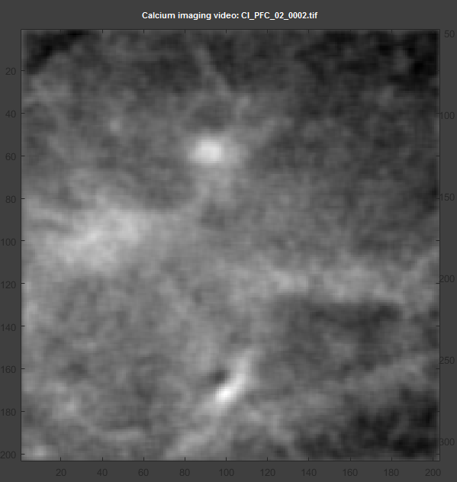

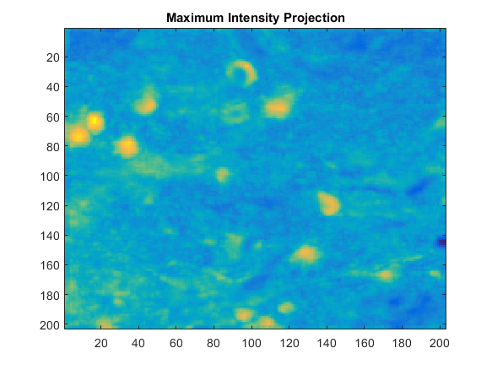The image above is saved in your origin folder and shows the maximum intensity projection of the whole ∆F/F processed video divided by the standard deviation of the whole ∆F/F video. In this image you can see cells in bright yellow and blood vessels are almost invisible, since they are static. This image shows only changes in brightness over time.

Furthermore your progress is saved at this point, so that if you want to load the same video again, you can continue where you left of. The ∆F/F video is saved as a MAT-file (**yourfilename**dFvid.mat) and whether the video has been aligned is saved as a variable (**yourfilename**vidalign.mat).

#### Cell detection/ ROI selection

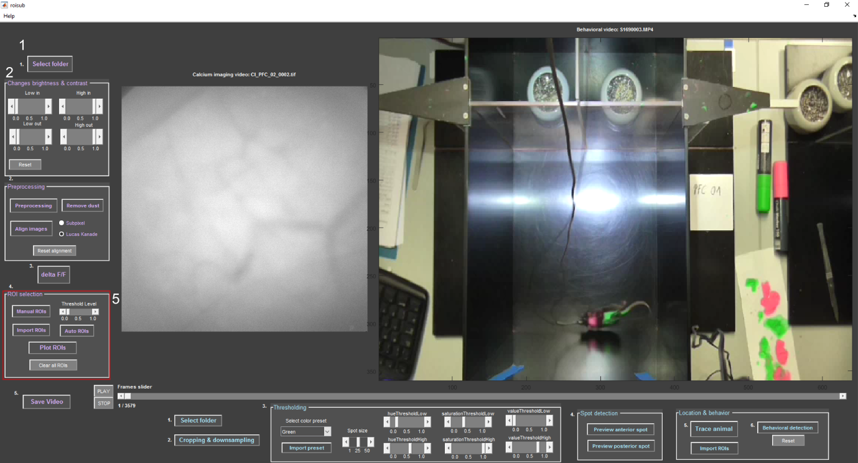

Manual ROI selection:

To manually identify cells press “manual ROIs” (5) and you will see the maximum intensity projection image as background. Then you can choose a desired area by clicking around it, like the pop-up instructions below suggest.

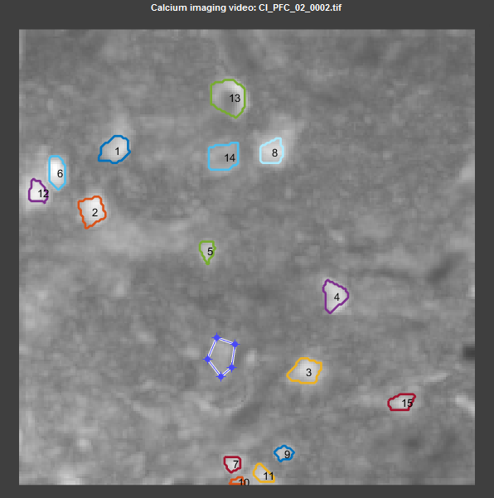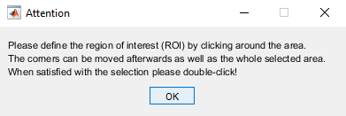

Selecting a new ROI.

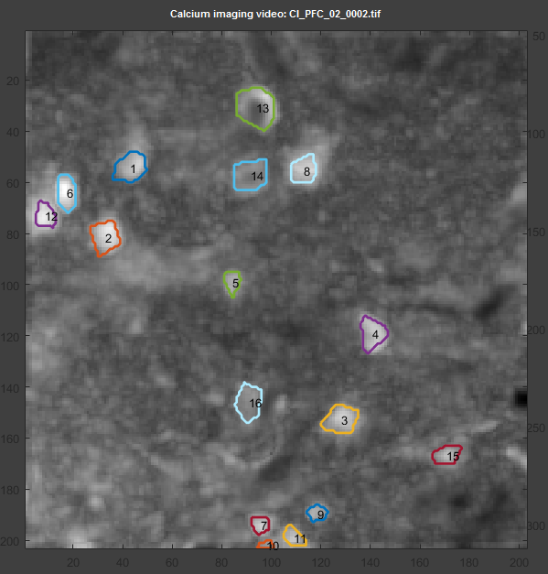

New ROI number 16 added to the ROI mask.

When you add ROIs for the first time, your progress with the ROI mask will be saved automatically. You will be asked however, if you wish to save the ROI mask, in case you remove, alter or add ROIs to an imported mask. You can alter ROIs by overlapping with a new ROI and removing parts of it. Naturally, you can also remove entire ROIs by overlapping. Note that when you alter or remove a ROI, the labelling of the ROIs changes.

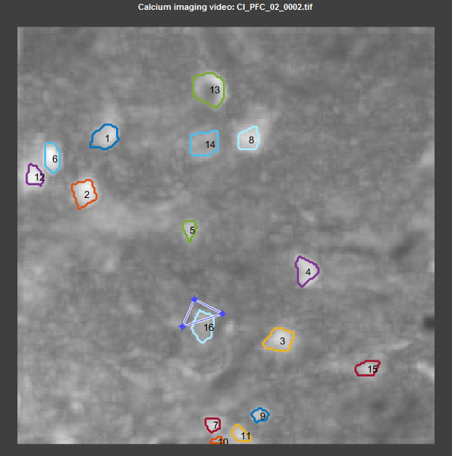

Removing a part of ROI number 16.

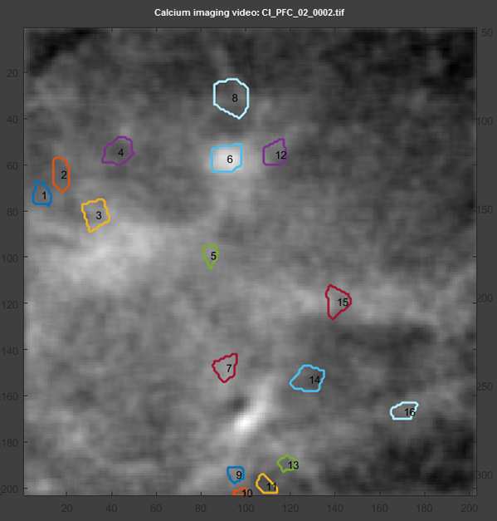

Result of removing part of ROI 16. That ROI is now number 7 after re-labelling.

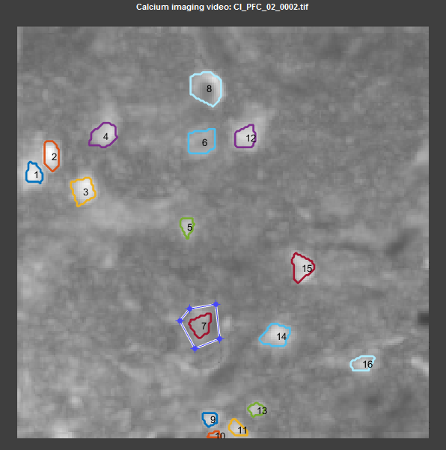

Removal of the entire ROI number 7.

By pressing “import ROIs” you are able to select a ROI mask from another batch or reload the already saved mask. The file containing the mask has the following structure: **yourfilename**ROIs.mat

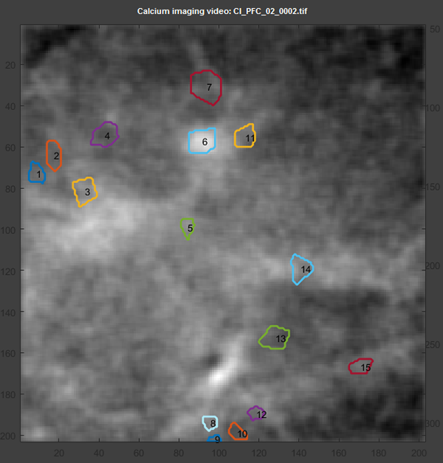

Result of removing ROI number 7. All ROIs have been re-labelled.

This is the same file that will be loaded in case you are re-opening the video and are asked if you want to load your last processed version.

Automatic cell detection:

#### Calculating values and plotting calcium traces

**

After selecting the cells from the video, you can plot the calcium traces by pressing “plot ROIs” (5). This will create plots with 8 ROIs per figure in different colours and with black dots over detected calcium spikes (see below). Furthermore, a raster plot will be created that summarizes all cell activity. These plots and an image of the ROI mask you used will be saved in the folder traces in your origin folder. In addition the folder contains an EXCEL-file with stats of the selected ROIs like total number of spikes, total spike frequency, and maximum amplitude. The MAT-file traces_**yourfilename**.mat is a structure array containing the frame rate of the video, the raw wave forms of the ROIs and the detected spikes with timestamps and amplitude.

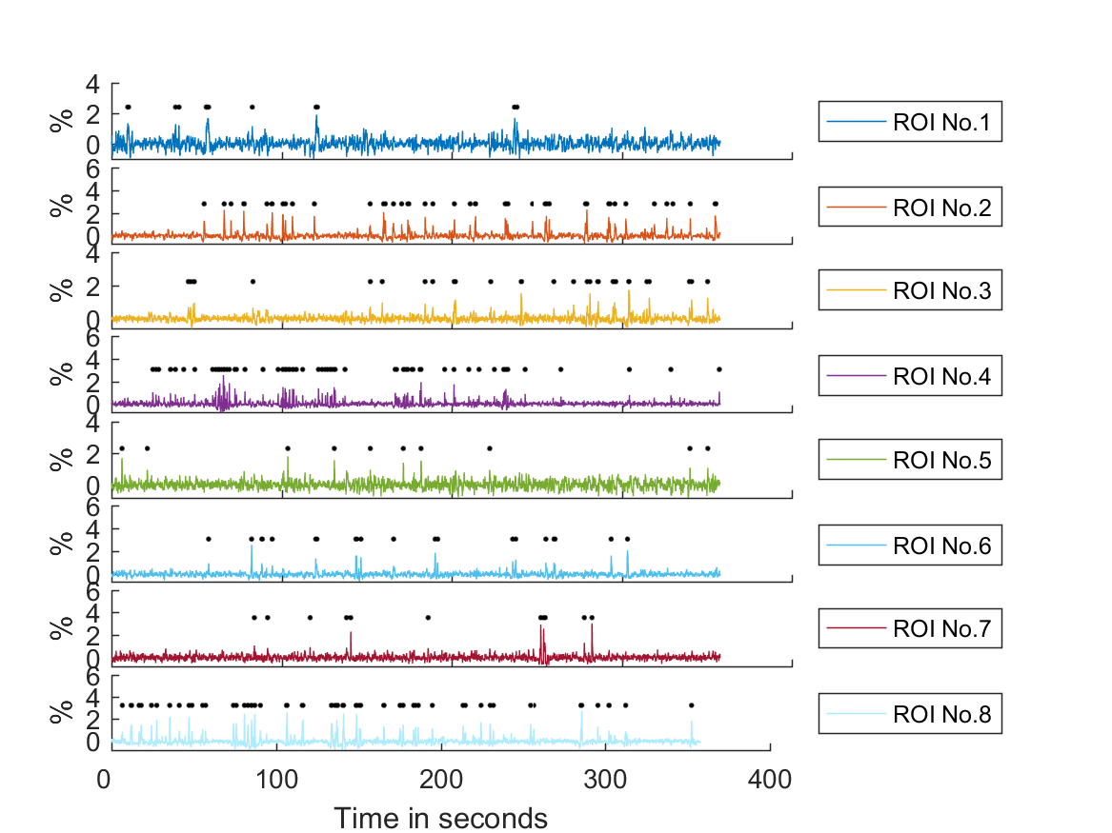

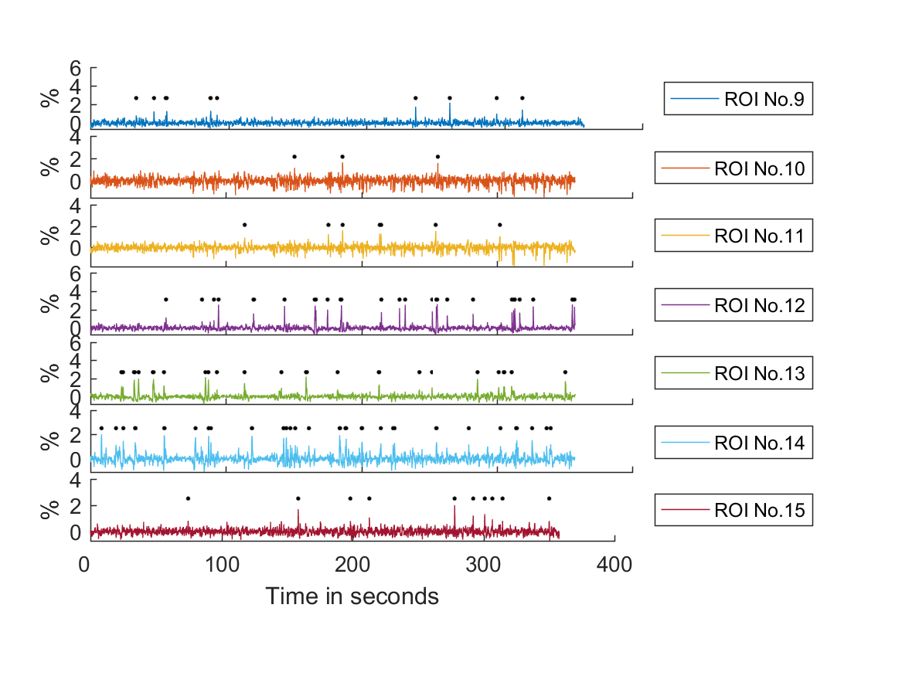

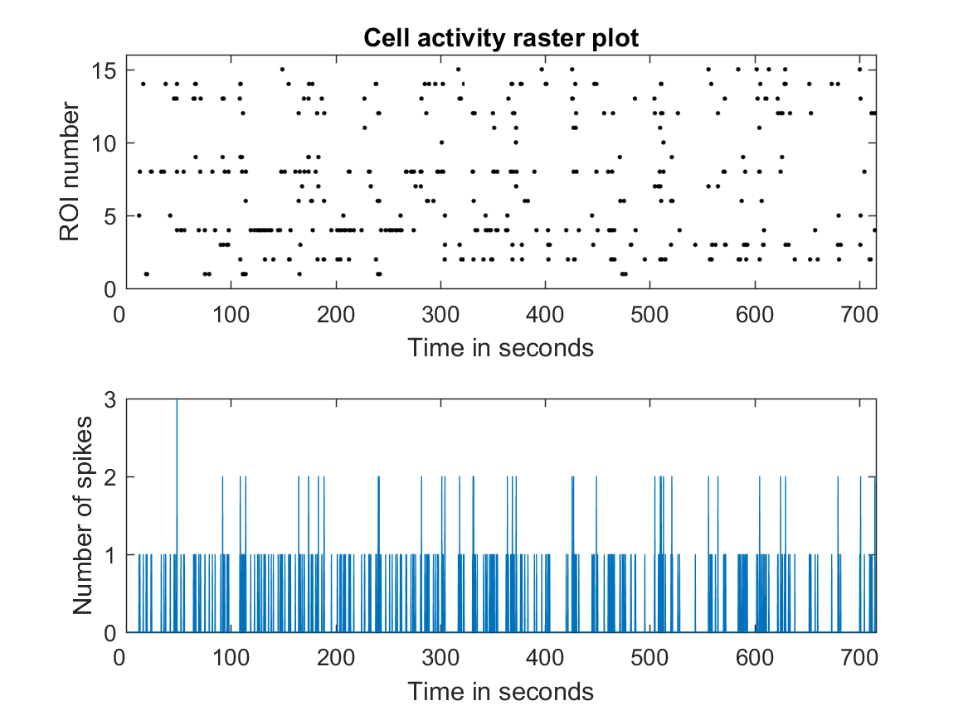

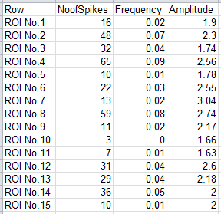

#### Optional: save video

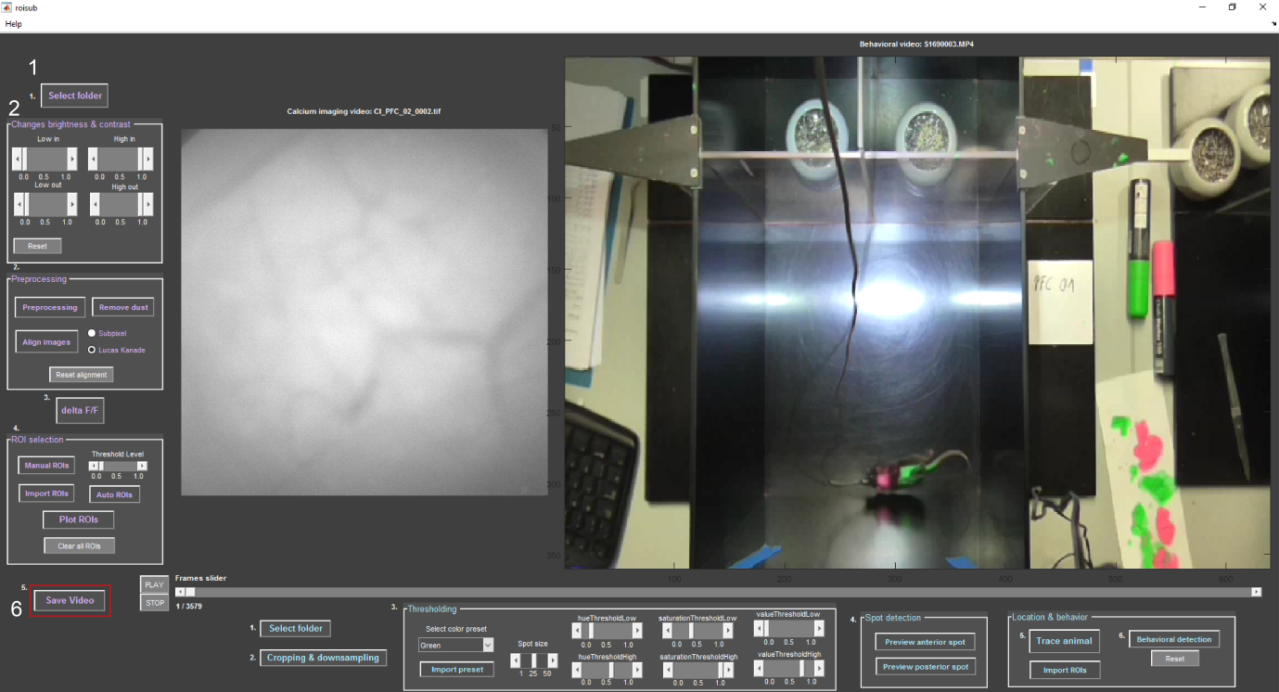

If you wish, you can export a processed version of the calcium imaging video as AVI-file (6). You have the option between exporting only the ∆F/F video and exporting the raw video overlaid by cell activity in red (see below).

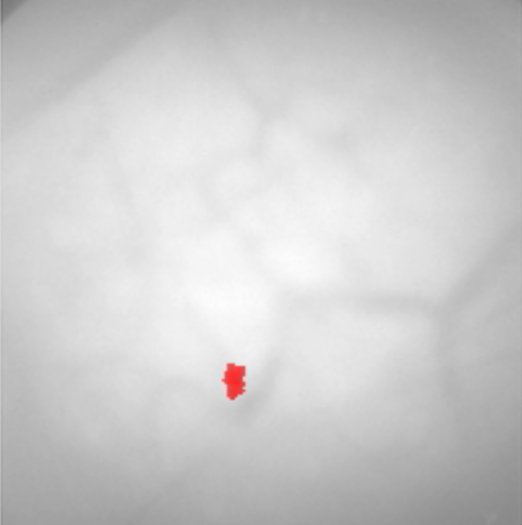

#### After processing behavioural video: re-plot calcium traces with behaviour

**

Once you completed the behavioural detection (II 6.), you can plot the tracked behaviour in the plots you saved before (I 7.), which looks like below. Each colourful bar stands for a certain behaviour that you defined during the behavioural detection. The colour code can be looked up in the mouse_behavior plot in the origin folder.

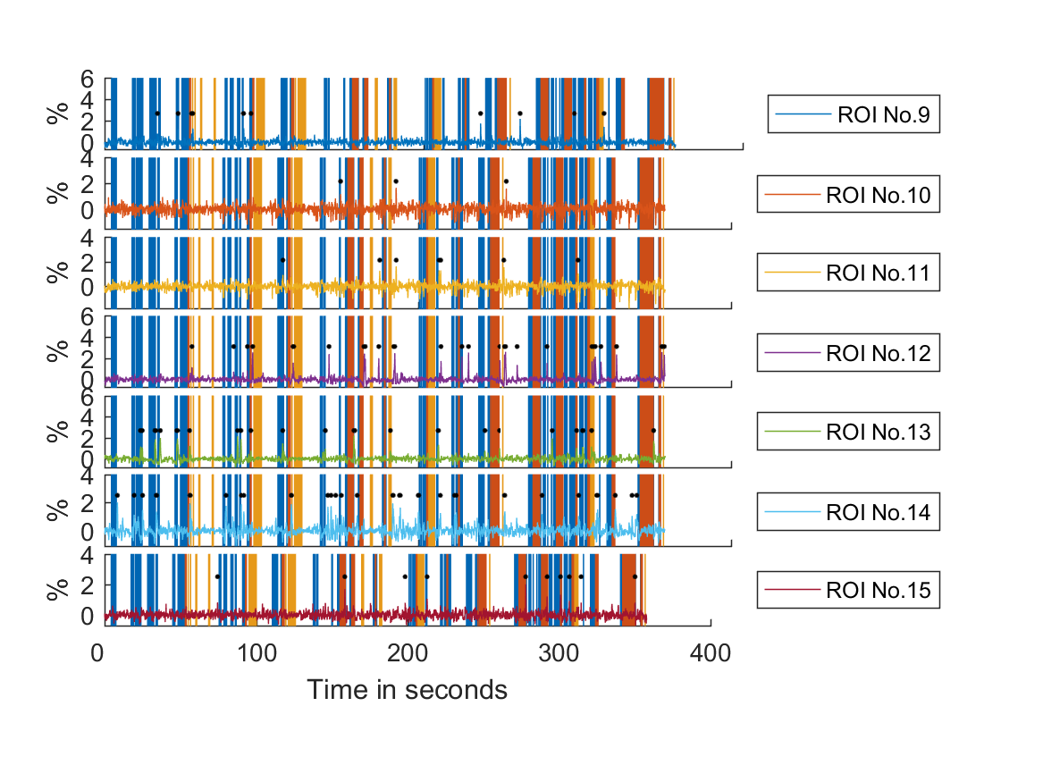

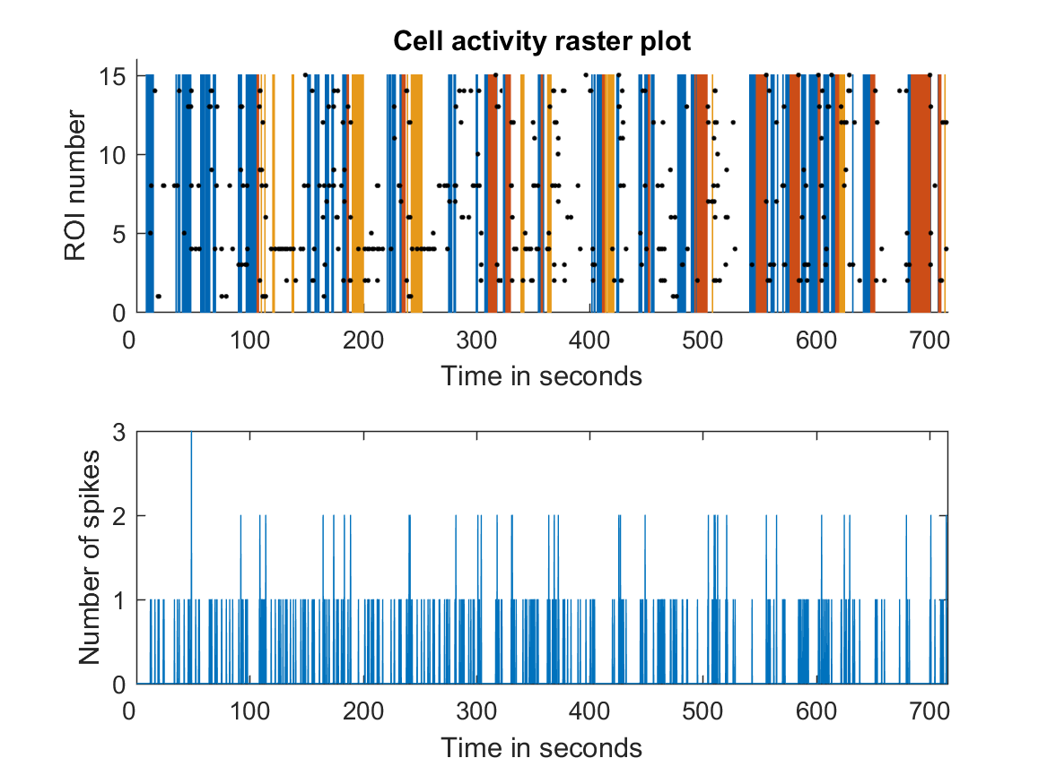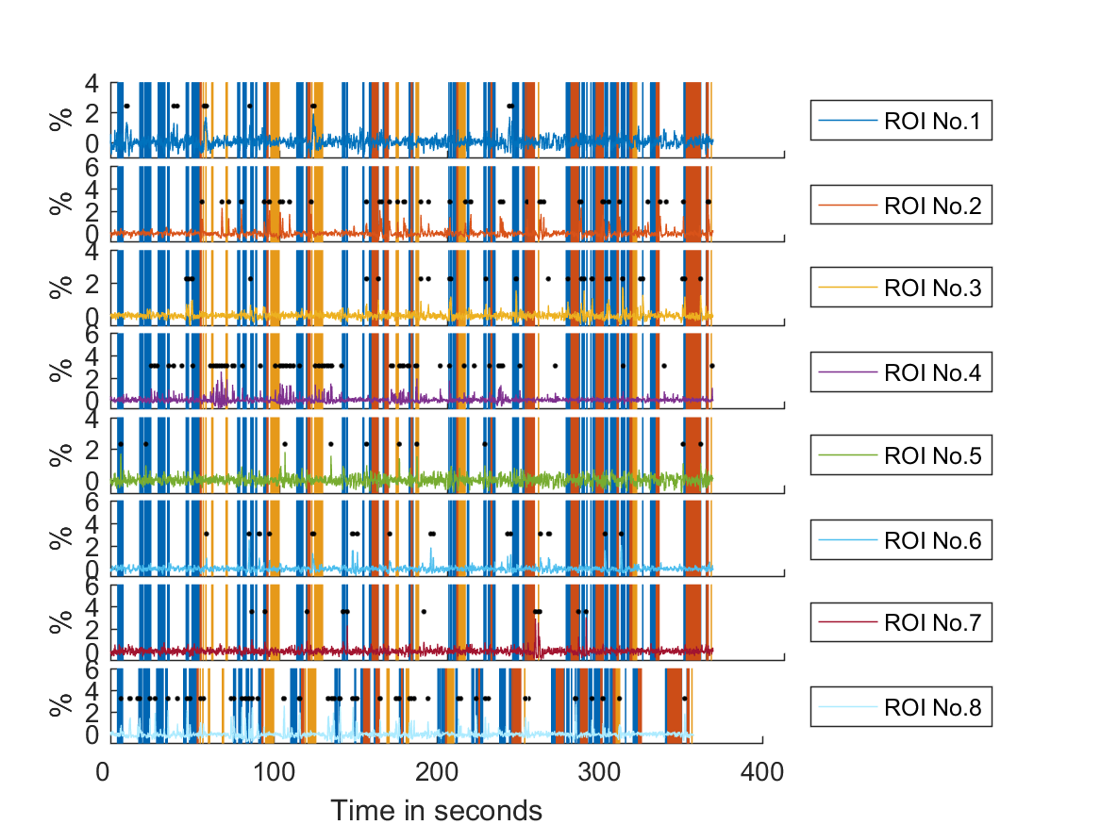

## II Workflow to process the behavioural video

#### Select Folder

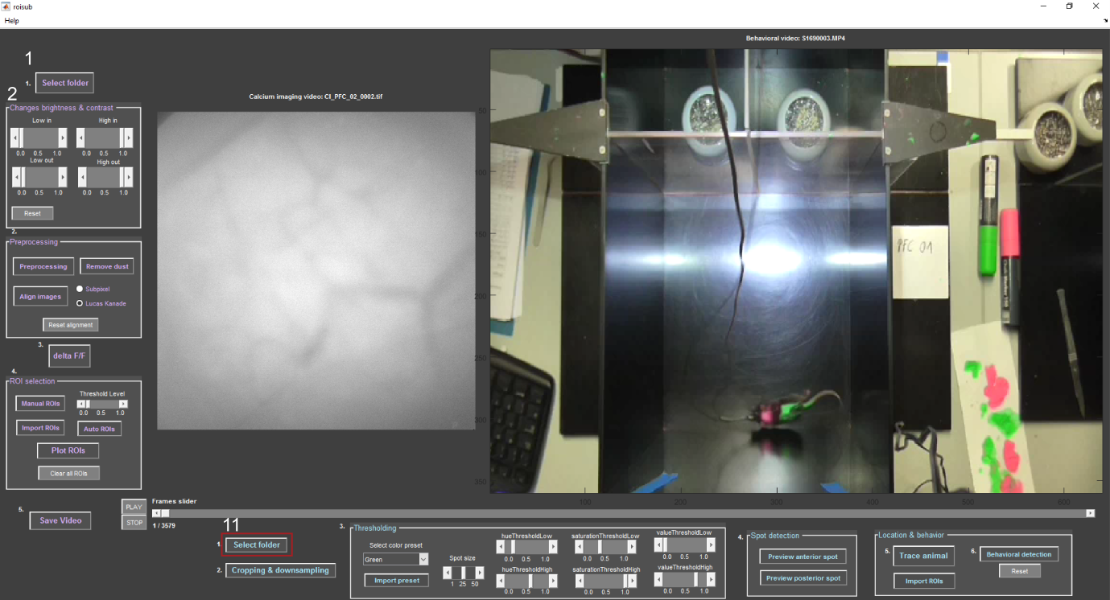

If you press “select folder” the directory will already be the same as the directory the calcium imaging video is from. The video will be loaded in a way that it matches the frame rate of the calcium imaging video. If the frame rate of the behavioural video is higher, it will only read every nth frame to match the frame rate from the calcium imaging video. If the frame rate of the calcium imaging video is higher, then it will duplicate the same frame until a new frame of the behavioural video is available.

In case you do not have an automated system that starts and stops both videos at the same time, you might lose some frames. Therefore a message box will inform you about the frames that were cut off (below). Positive number means the behavioural video was shortened, negative number means the calcium imaging video was shortened.

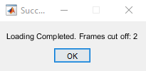

#### Crop and down sample the video

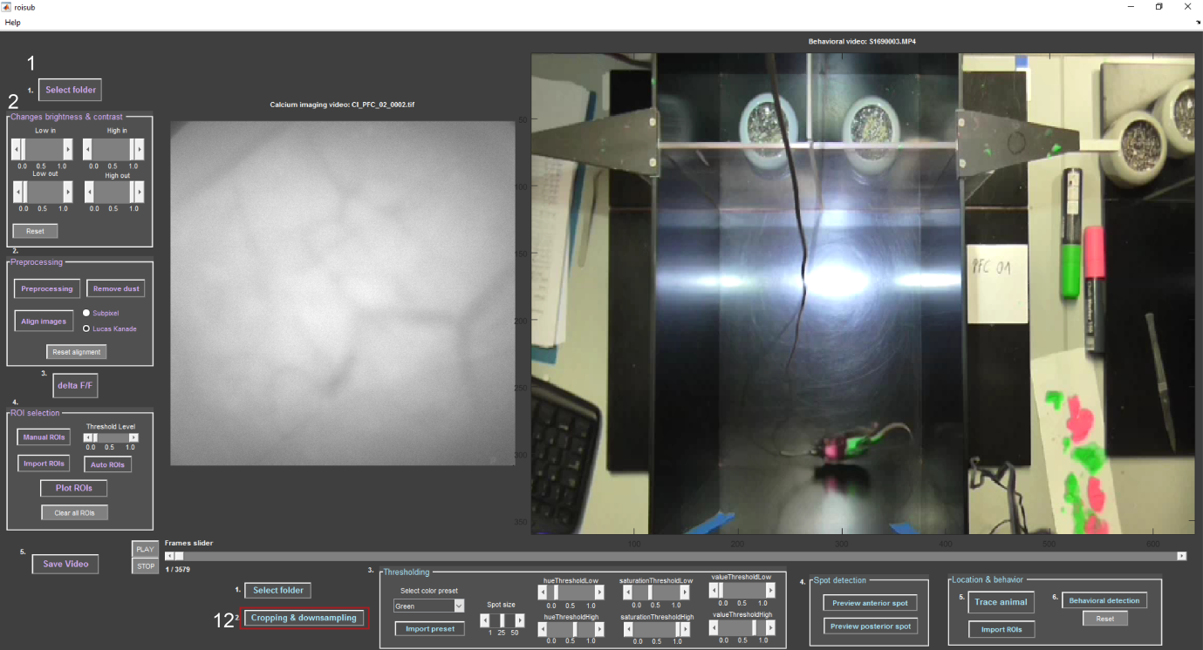

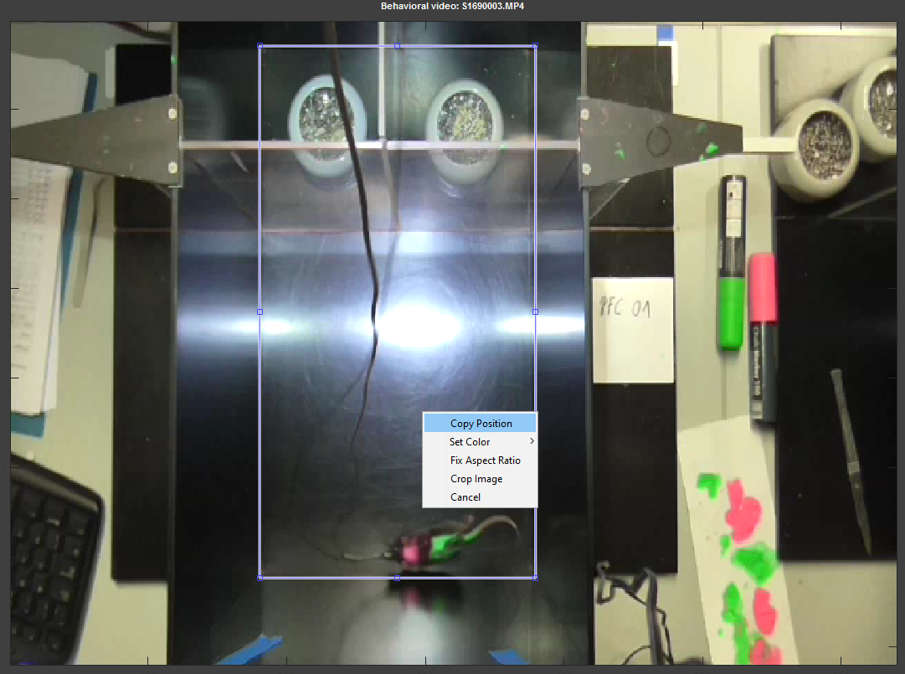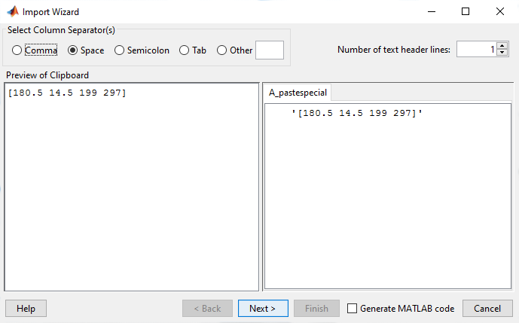Next crop the video (12) by defining the testing area, right-click, and copy position. The import wizard will guide you through the next step of importing the location of your defined ROI (below). Click “next” and then “finish”.

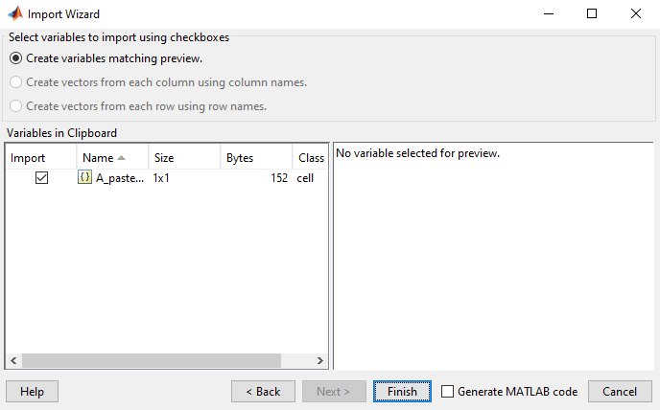

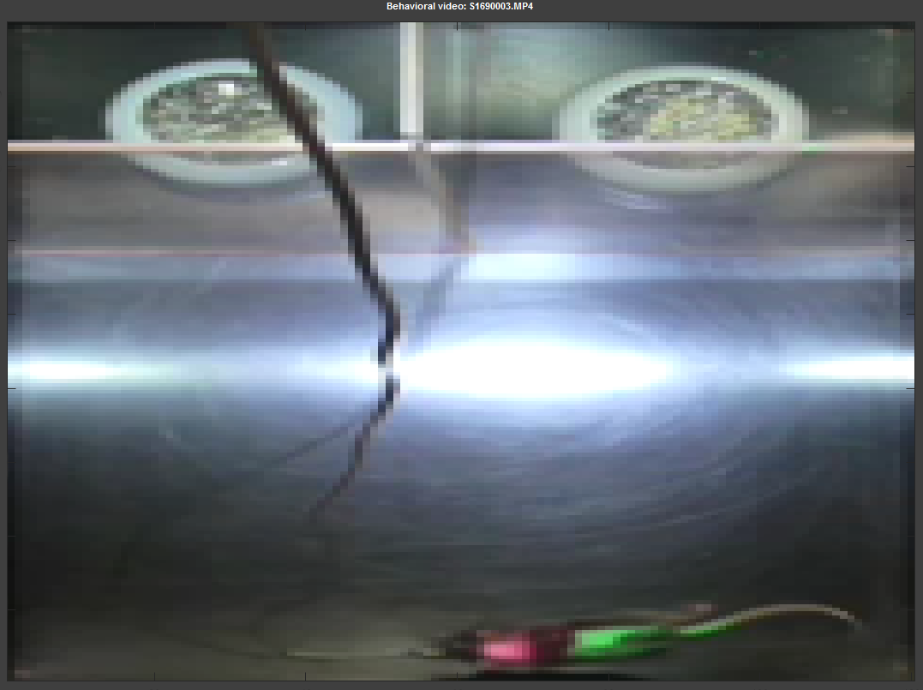

Result from cropping and down sampling.

The resulting video is saved as progress so it can be loaded if you open the same file again (**yourfilename**_converted.mat).

#### C:\Users\Asspen\Documents\PhD\MatlabGUI\help\overview08.pngDefine mask for tracking colour spot(s) of the animal

To track the location of the mouse you must have at least on coloured spot on your animal. To track orientation of the animal you need two spots, naturally. In order to create a mask of a colour, you need to adjust the hue, saturation, and value thresholds (13). In the drop-down menu you already have a selection of different colours where those values are predefined. The choices are green, pink, yellow, and blue. To select a pre-set, click on the respective colour in the drop-down menu. You will see a preview of the spot like below for green and pink.

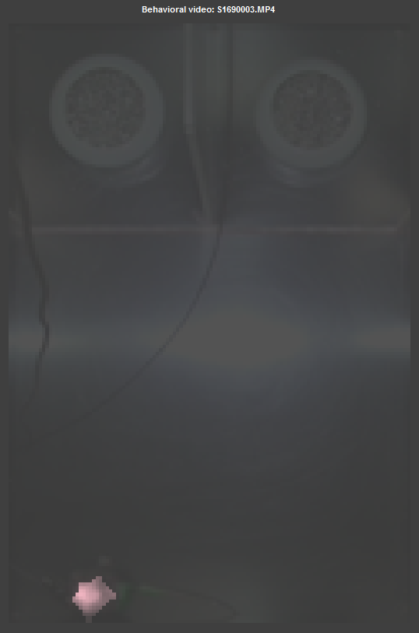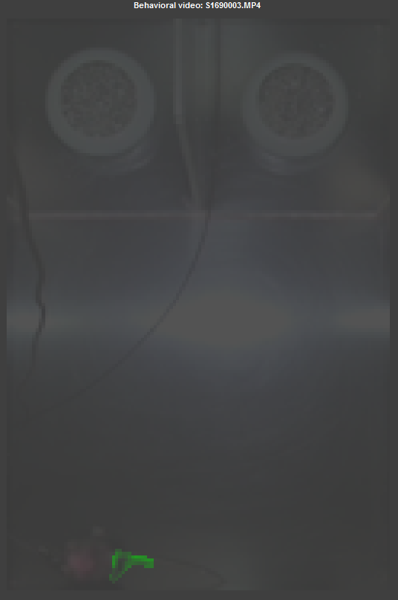

If the spot cannot be detected with the current mask, it will be displayed in the video (Mouse out of bounds.). This could be for multiple reasons, the mouse is not visible, the spot is too small or the values for the different thresholds are wrong. If the mouse is out of bounds you will still be able to determine that by the faint image of the current frame. If the spot is too small, you can adjust the cut off size with the slider “spot size”. This will adjust the threshold at which small objects are removed to avoid noise. If the thresholds are wrong, try selecting a pre-set; otherwise adjust the different thresholds until you see a coloured mask.

To make it easier for long experiments that are repeated every day, there is the option to import a pre-set. Pre-sets are saved after you “preview the spot” (next chapter) into the MAT-file presetA / presetP for the anterior or posterior spot respectively. If you have only one spot on your animal, it counts as the anterior spot. By pressing “import preset”, you can select settings you took in a previous experiment. If you have both pre-sets saved, a pop-up will ask you, which one you would like to import (see below). If you had only one spot it will automatically load the pre-set as anterior spot.

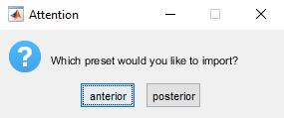

#### Preview and save tracking

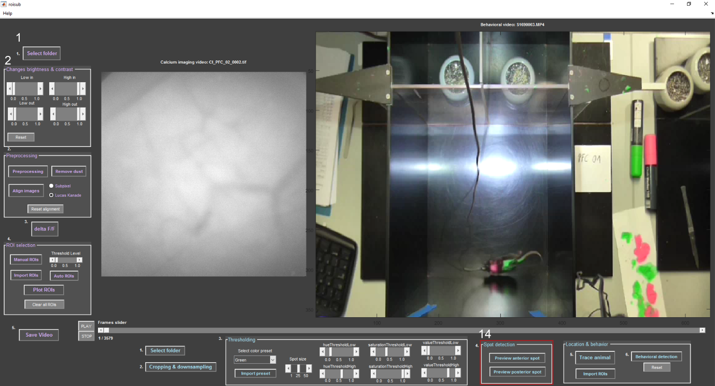

Once you determined your coloured mask, you can preview the tracking of the mouse by pressing “preview anterior/posterior spot” (14). It will track the mouse in the colour of the spot you selected and display in how often the animal cannot be tracked in percent (red text). Then you adjust the thresholds and preview again or proceed with the next spot. If both spots are tracked, proceed to tracing the animal.

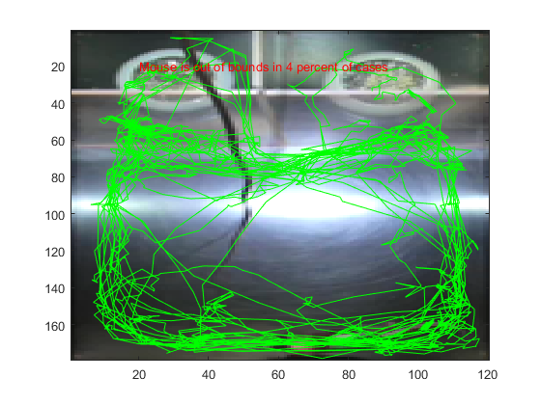

#### Trace the animal and plot locations correlating with cell activity

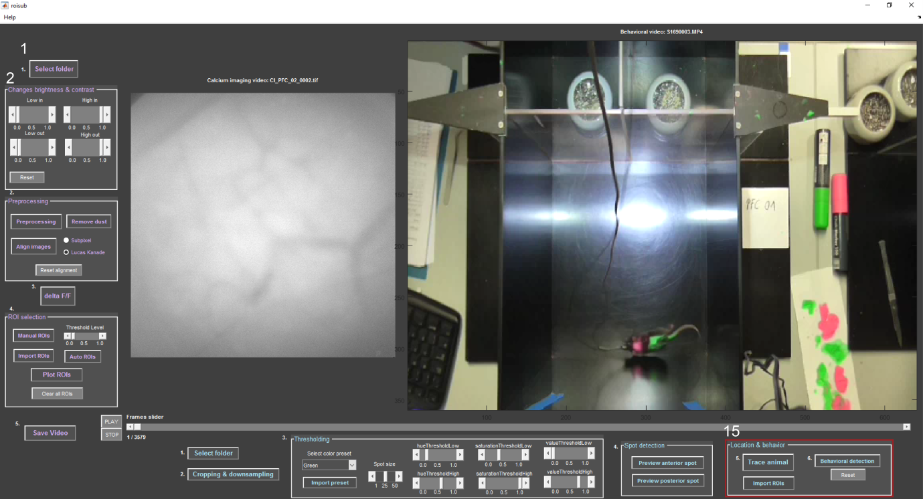

By pressing “trace animal” you will first get a plot of your spot(s) like below.

Second, you determine the factor for translating pixels to cm by defining one length of the testing area as follows: draw a line, right-click, and copy position. Then follow the import wizard with “next” and “finish” to import the length of your line. 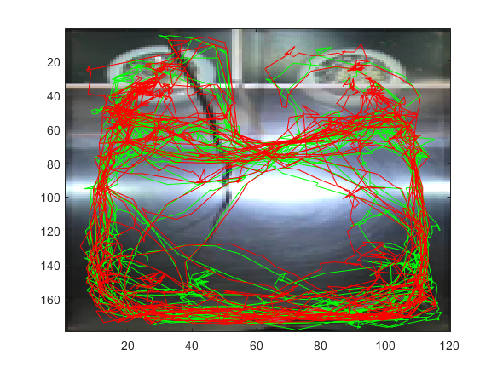

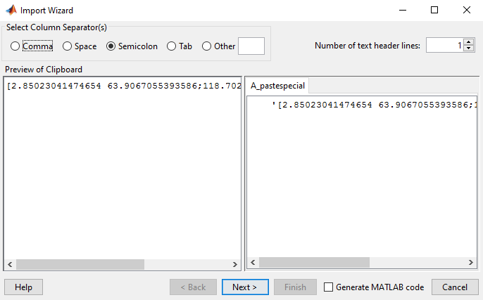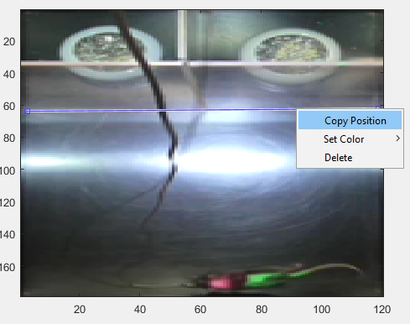

Then type in the real length in cm.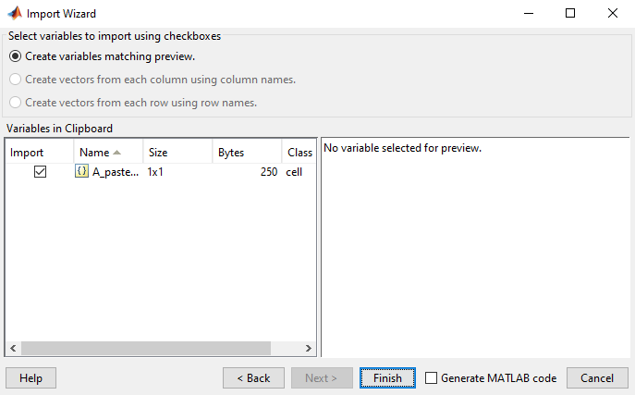

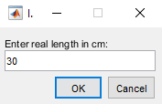

Next you will be asked if you would like to define regions of interest. These ROIs will be used to calculate how much the mouse was present in each ROI (in percent). Here is an example for how you can select such ROIs: First define how many ROIs you want to select. Then you have to define the first ROI, afterwards you name it. This process you repeat as many times as you have ROIs. The ROI locations will be saved in a MAT-file (tracingROIs.mat) that can be imported by pressing “import ROIs”. This makes it easier in the following experiments.

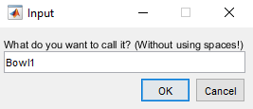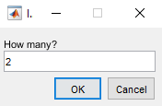

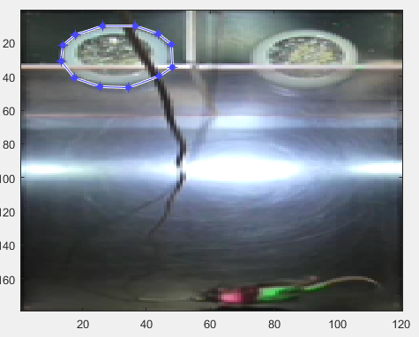 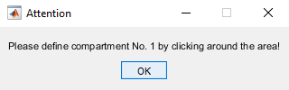This will give you an EXCEL-file showing your ROIs and the amount of time the animal spent in those ROIs in percent. The animal is registered as within the ROI, when the center of the anterior spot lies within.

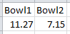

The question whether the mouse ever leaves the testing area pops up when it was not possible to track the animal 100% of the time. If you choose “yes” it will be assumed that in the cases where the animal was not visible stayed at the previous location. If you choose “no” the times the animal could not be tracked is noted in red text in the figure in percent.

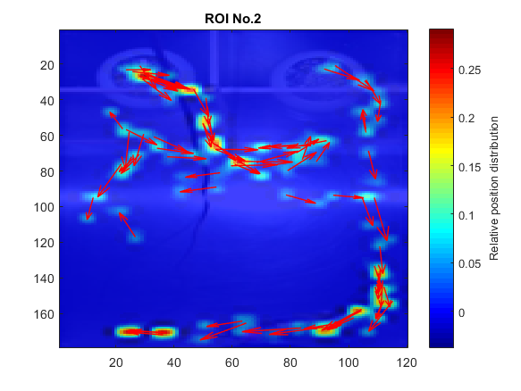Finally, the program will correlate the cell activity found in the calcium imaging video with the location of the mouse. Here fore it plots every location of the animal at which a spike occurred (black dot in the plots) in a heat map. If you had two spots on the mouse, it additionally plots the direction the animal was heading in. Below are two examples. The plots are saved in the folder location in your origin folder.

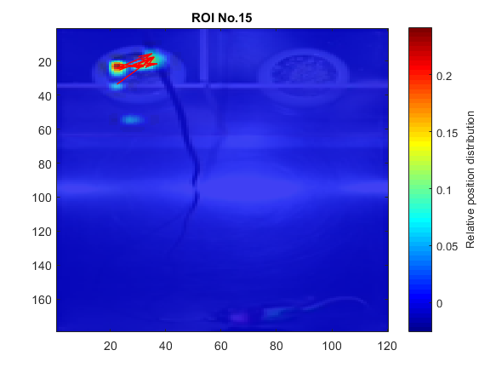

Lastly, the program will save an EXCEL-file containing the total distance the animal travelled in cm, the mean velocity in cm per second, the percentage the animal did not move, and the percentage the animal was out of view.

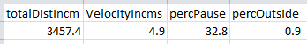

#### Behavioural detection

**

By pressing “behavioural detection” (15), you can define up to 8 different behaviours. First, you type how many behaviours you would like to track. Then you define the short key for the first behaviour and how the behaviour should be called. This process you repeat as many times as you have behaviours.

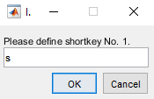

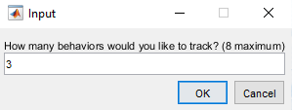

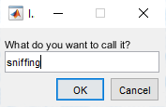

Then the behavioural video is played from the beginning and you can start pressing your short keys. You can choose to press only one key and go through the whole video and then press “behavioural detection” again to play the video and press the next short key; or you can press all short keys in one run. You can run the video and press the short keys as many times as you want once you defined the behaviours. Once the video stops, a plot like shown below will pop up. The plot will be saved in your origin folder. If you wish to reset the defined behaviours and short keys, press “reset”.

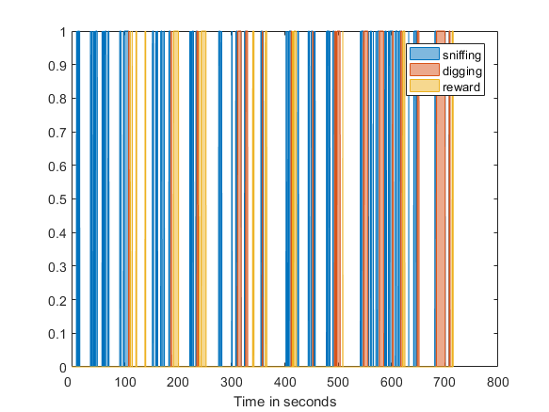

28/02/2017 Jennifer Tegtmeier roisub.m